Vientian Laos

[July 2, 2015]
Amaury Rolin &
Serge Doussantous
Subject

2105 Baseline HEF Perfomance Analysis for Sekong Porvince

Summary
1 Summary 3
2 Abbreviations 3
3 Survey Background 4
4 Population Statistics 4
5 Out of Pocket Costs 5
General Outpatient and Inpatient OOP Rates 5
General Outpatient and Inpatient Costs 6
Total Cost Estimates for Individuals and HHs 7

Summary

Abbreviations
SRC | Swiss Red Corss
HH | House Hold
HC | Health Center
PH | Provincial Hospital
DH | District Hospital
PC | Private Clinic
PP | Private Phamacy
RH | Religious Healer
HV | Village Health Volunteer
TH | Traditional Healer
ICR | Indochina Research
OOP | Out of pocket Payment
HEF | Health Equity Fund
MNCH | Maternal Newborn Child Health
CU2 | Children Under 2
CU5 | Children Under 5

Survey Background

This is an analysis of data collected for the SRC by ICR in March 2015 in Sekong Province. The survey seeks to establish a baseline measurement of health care coverage in Sekong Province. Of particular interest is the amount being spent out of pocket by the various constituencies.
The survey interviewed a total of 930 HH with a total count of 6556 individuals in 60villages. The survey was stratified between two geographic areas which implement different HEF coverage schemes. The first scheme is a universal coverage scheme implemented geographically for portions of the province known to have high endemic poverty and relatively small villages. These villages and households will be referred to as GeoID. A target was set, and met, of interviewing 270 HHs from the GeoID areas.
In the non GeoID areas HEF services are targeted to HHs which have been per-qualified based on falling bellow a threshold in a poverty assessment. These households will be referred to as PreID. A target of 270 PreID HHs were surveyed. In the same geographic area an additional 360 HHs which do not qualify for HEF insurance were surveyed. These are referred to as NoAssist in this report.
The households were sampled in a systematically randomized way by running through the villages list of inhabitants and taking every Nth inhabitant. A target number of CU2 households was set a 211. Some of the randomization was eschewed in favor of reaching this target. A resultant 366 mothers were surveyed.

Population Statistics

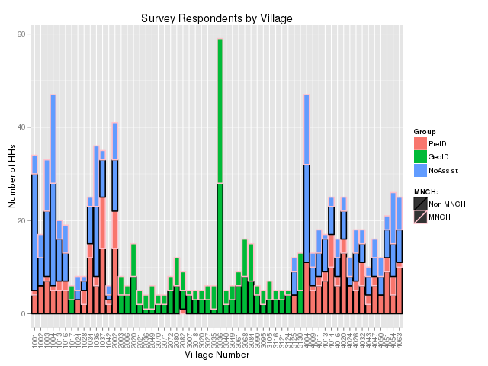

Out of Pocket Costs

General Outpatient and Inpatient OOP Rates
The survey asked respondents about the cost of their last outpatient, and last two inpatient procedures. Here we look at the 3 classes of facilities covered by the HEF fund (Health Centers [HC], District Hospitals [DH] and Provincial Hospitals [PH]) and what percent of respondents responded with a cost of 0Kip to these questions and it's sub parts.
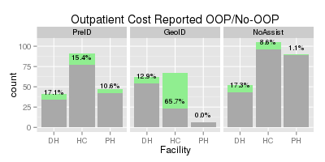 | 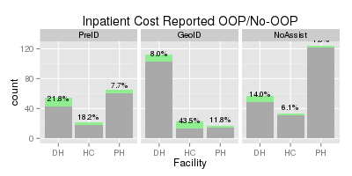
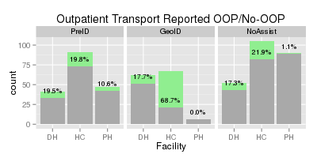 | 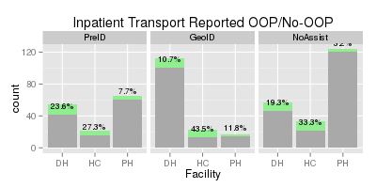
The height of each bar indicates the total number of respondents who provided cost of care information by group and facility. The green portion of each bar indicates the number that reported 0Kip or No-OOP as the cost. The percent represented by the green area is overlaid on each bar.
No-OOP responses are fairly low across the board. It is evident from these plots that most respondents incur at least the cost of transportation. Only the GeoID respondents show a majority of respondents have No-OOP cost when visiting a health center for outpatient procedures.

As transportation appears to be the limiting factor for respondents reporting No-OOP cost, we are particularly interested in whether they report OOP for medical fees or medicines. These are covered by the HEF fund and can be better controlled by the fund since they occur at the facility and do not involve disbursing cash. The OOP rates for these are plotted below.
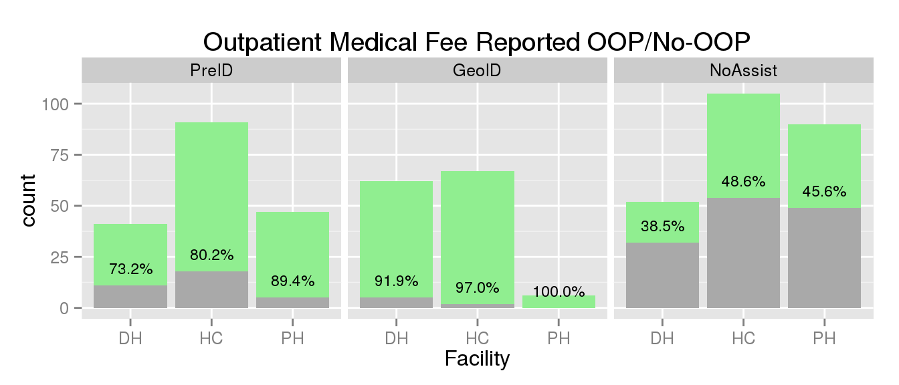 | 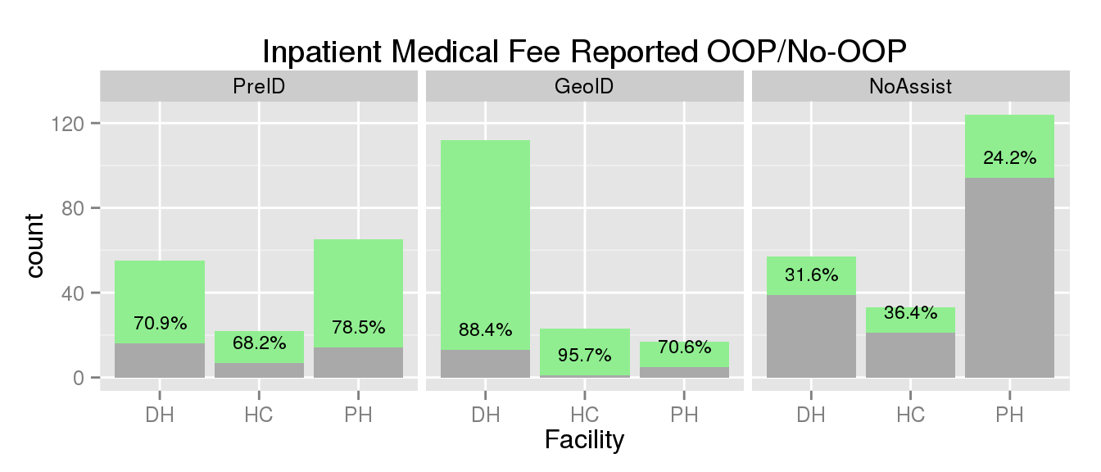
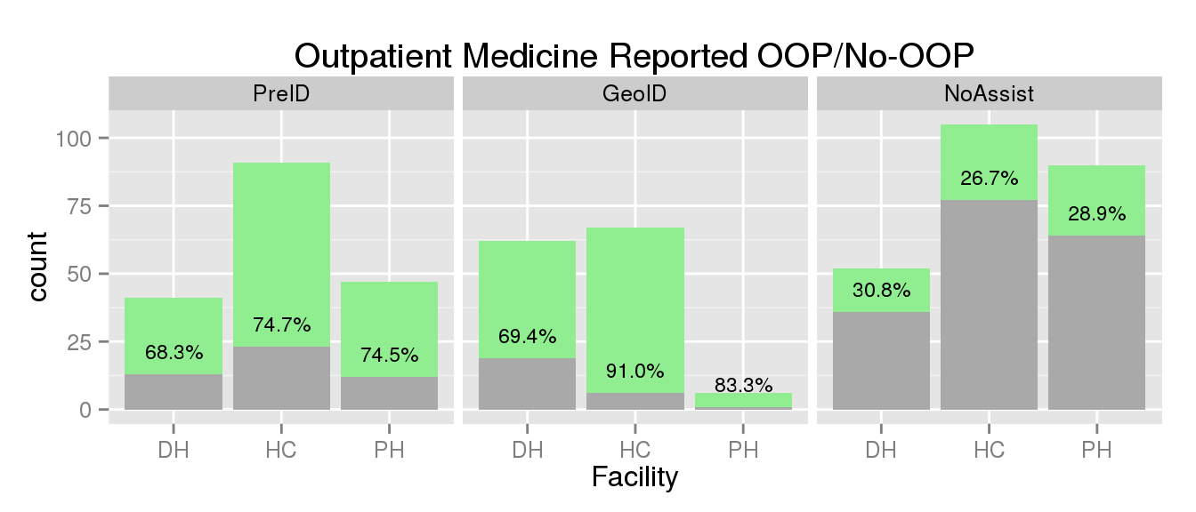 | 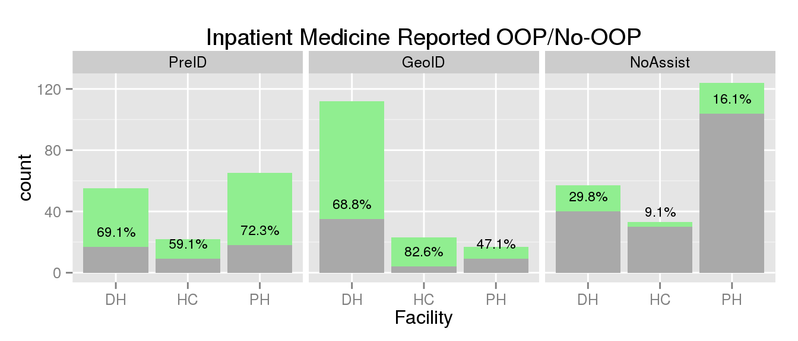

We see that:
- Health Centers attended by the GeoID have the best coverage
- Coverage rates are relatively consistent between in and outpatient events.
- The district hospitals have a poorer rates of coverage, particularly as concerns medicines.
- There are surprising number of NoAssist reporting No-OOP, some of this is due to coverage for children under 5 being universal
  - 64% of outpatient and 36% of inpatient No-OOP responses for medicine are for CU5
    - Of 11 of 22 remaining non paying NoAssist Outpatients are Civil Servants
    - Of 11 of 26 remaining non paying NoAssist Inpatients are Civil Servants
  - 38% of outpatient and 25% of the inpatient No-OOP responses for medical fee are CU5

General Outpatient and Inpatient Costs

A key indicator of interest are the total yearly costs per person in the province. To find this number form the survey, a model was created to assign a cost to each event reported by each individual. The model assigns a cost to an event based on:
- Whether the event was inpatient or outpatient (IO)
- Which facility type the event was treated in (F)
- Which insurance group the individual belongs to (G)
- Whether the individual is a CU5 (CU5)
To avoid outliers driving up the costs, and to account for the fact that some categories, particularly when broken down at the facility level, would have little or no cost information in the survey the following formula was used to create the cost model:

When no cost information was available at the facility level, only the right hand side fraction was used.
All outpatient costs above 500,000Kip were removed and all inpatient costs below 1,000,000Kip were removed.
Without accounting for facility (the right hand fraction) our estimates of average cost appear as follows:

Accounting for facility we come up with the following models:
The top row of each table is the overall group average without a breakdown by facility. In the event that no more detailed cost information exists, this top value is copied down and is left in white. Facilities who's modeled cost is above the group average are highlighted in light orange, while facilities below the group average are highlighted in light green.
According to these models, the district hospital, health centers, and village health volunteers tend to be lower cost, though there are some exceptions by group and service type.

Total Cost Estimates for Individuals and HHs

The cost model described above was applied to each individual in the survey by counting each event reported by that individual for in and out patient, and adding in the cost from the entry in the costing model corresponding to the insurance group and CU5 status. The result of the mean yearly cost by individual (Indv) and household (HH) counting only the individuals who have any events are presented in the table below:

We see that the PreID and Geo ID have very similar outpatient costs by individual and that it is less than half that of the NoAssist. We also see that PreIDs do nearly as well on Inpatient and Outpatien services, while the GeoIDs incur most of their costs in inpatient events. We also see that the HH cost is reduced 2.8x HEF insurance in the same geographic areas, and are 1.8x lower in the GeoID areas. Note that the provincial estimates include individuals with no events so the averages are lower but more accurately reflect the mean cost spread over all Individuals. Since all HH have at least one event, the HH estimate is not affected by this neuance.

Catastrophic Events

